BOOKS ABOUT WAVES
Non-Fiction
- Seeds of Science Light and Energy Teacher’s Guide
- The Wave Watcher's Companion: From Ocean Waves to Light Waves via Shock Waves, Stadium Waves, and All the Rest of Life's Undulations Fiction by Gavin Pretor-Pinney
  - Book Review
- 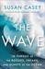The Wave: In Pursuit of the Rogues, Freaks, and Giants of the Ocean (Hardcover)
by Susan Casey
- Semilinear Schrdinger Equations (Paperback)
by Thierry Cazenave
- 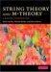String Theory and M-Theory: A Modern Introduction (Hardcover)
by Katrin Becker
- 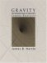Gravity: An Introduction to Einstein's General Relativity (Hardcover)
by James B. Hartle
- 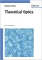Theoretical Optics: An Introduction (Hardcover)
by Hartmann Römer
- 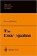The Dirac Equation (Hardcover)
by Bernd Thaller
- 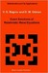Exact Solutions of Relativistic Wave Equations (Hardcover)
by V.G. Bagrov
- 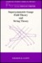Supersymmetric Gauge Field Theory And String Theory (Hardcover)
by David Bailin
- Quantum Field Theory (Hardcover)
by Lowell S. Brown
- 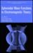Spheroidal Wave Functions in Electromagnetic Theory (Hardcover)
by Le-Wei Li (shelved 1 time as waves)
- 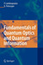Fundamentals Of Quantum Optics And Quantum Information (Paperback)
by Peter Lambropoulos
- 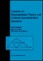Lectures on Representation Theory and Knizhnik-Zamolodchikov Equations (Hardcover)
by P.I. Etingof
- 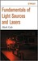Fundamentals of Light Sources and Lasers (Hardcover)
by Mark Csele
- 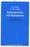Supersymmetry and Supergravity: (Revised Edition)
by Julius Wess
- 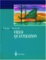Field Quantization (Paperback)
by Walter Greiner
- 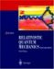Relativistic Quantum Mechanics. Wave Equations (Paperback)
by Walter Greiner
- 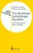The Nonlinear Schr Dinger Equation: Self-Focusing and Wave Collapse (Hardcover)
by Catherine Sulem
- 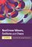Nonlinear Waves, Solitons and Chaos (Paperback)
by Eyrk Infeld
- 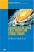Cosmology in Gauge Field Theory and String Theory (Paperback)
by David Bailin
- 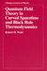Quantum Field Theory in Curved Spacetime and Black Hole Thermodynamics (Paperback)
by Robert M. Wald

