Carbon Dioxide - Sources and Sinks
Summary: | Students will use a chemical indicator (BTB) to detect the presence of carbon dioxide. | Materials:  For each four-student team  - Test tube rack  - Six test tubes  - One hole stopper with tubing attached  - Baking soda  - Vinegar  - Aluminum foil  - Cotton balls  - Bottle of BTB working solution  - Straws  - Sprig of Elodea (available in pet stores)  - Masking tape  - Markers
Source: | Adapted from Global Climates - Past, Present, and Future. EPA Report No. EPA/600/R-93/126 and recommended by Sandra Henderson
Time: | This activity requires careful preparation including some set-up the previous day. It is recommended that the directions be read carefully before beginning this activity.  - Materials preparation: 40 minutes  - Class time: 40 minutes  - Discussion & review: 30 minutes
Student Learning Outcomes: | - Students will be able to explain the concept of 'sources' and 'sinks' as they relate to carbon dioxide.  - Students will understand the use of an indicator solution (BTB) to reveal the presence of carbon dioxide.  - Students will understand the qualitative differences between animal and fossil fuel sources of global carbon dioxide.
DIRECTIONS:
This activity has significant set up time. Part 3 will require set up the previous day. You may want to do Part 5 (fossil fuels) as a demonstration as it involves automobile exhaust which contains carbon monoxide (CO).
- In Part 1, students will gain experience in detecting CO 2 through the BTB reaction by using a pure CO 2 gas made from the reaction of baking soda and vinegar
- In Part 2, students will determine if animals are a source of CO2
- In Part 3, students will determine if plants are a source of CO2 (through respiration)
- In Part 4, students will determine if plants are a sink for CO2 (through photosynthesis)
- In Part 5, students will determine if fossil fuels are a source of CO2
PART 1: DETECTING CO 2 GAS
- With masking tape, label 5 test tubes A thru E. A will serve as the control. One test tube will be left unmarked.
- Gather the unmarked test tube and test tubes A and B, a test tube rack, a test tube stopper with a length of tubing attached, BTB solution, vinegar, baking soda, 1 inch square of aluminum foil, and a cotton ball.
- Fill test tubes A and B approximately 1/3 full with the BTB solution and place in the rack. Test tube A will be used as a control.
- Fill the unmarked test tube approximately 1/4 full of vinegar.
- Using the foil, make a small "boat" for the baking soda - fill 1/2 full of baking soda.
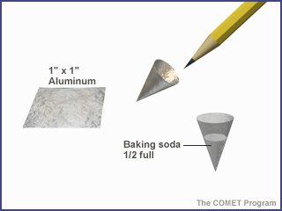
The 'boat' should be small enough to easily fit into the test tube and float on the vinegar.
- Carefully slide the foil boat inside the unlabeled vinegar test tube (it is useful to tilt the tube at an angle to accomplish this)
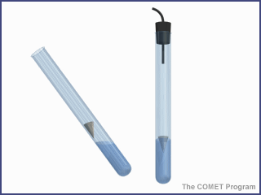
- Plug the tube with the stopper and tubing.
- Place the free end of the tubing in tube with BTB, making sure the end of the tubing reaches the bottom of the tube.
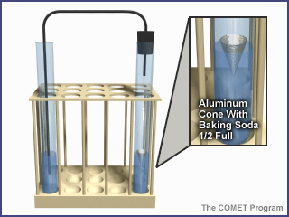
- Place a cotton ball into the neck of the tube with BTB.
- Mix the vinegar and soda together by GENTLY swirling the tube from side-to-side. Don't shake it upside down! Gas bubbles will begin to bubble rapidly out of the tubing into the test tube with BTB
- Note the color change. What happened?
Part 2: Are animals a source of CO2?
- Fill a test tube C approximately 1/3 full of BTB
- Place a straw in the test tube.
- Place a cotton ball in the test tube opening.
- Gently blow in the straw
- Note the color change. What happened?
Part 3: Are plants a source of CO2?
- Fill test tube D approximately 1/3 full of BTB
- Place a sprig of Elodea into the test tube (Use a pencil or pen to push it all the way into the bottom of the tube)
- Wrap the tube in foil so that no light can get in.
- Place in test tube rack and leave for at least 24 hours.
- Unwrap the foil and note the color change. What happened?
Part 4: Do Plants take up CO2?
- Using the now-unwrapped test tube with Elodea from Part 3, leave in the light and observe the BTB color change.
- What happened?
Part 5: Are Fossil Fuels a Source of CO2? (Recommended as a teacher demonstration)
- Fill test tube E approximately 1/3 full of BTB
- Take the exhaust filled balloon, carefully untwist the tie while holding the neck of the balloon so that the gas does not escape. Twist and pinch the neck of the balloon to prevent air from escaping, but don't tie it.
- While still preventing the gas from escaping, insert a straw into the neck of the balloon up to the twisted portion. Have one team member seal the opening of the balloon tightly to one side and pinching it off with their fingers. You may need to practice this a few times with a regular air-filled balloon.
- Insert the straw into test tube E.
- Insert a cotton ball not the top of test tube E to help hold the straw steady.
- Gently release air from the balloon by slowly untwisting the neck. Allow the gas to bubble out at a steady rate until the balloon is empty.
- What happened?
After finishing all five parts of this activity, compare the colors in all the tubes. Are they different? If so, why?

Automobile exhaust collection
Important note: Carbon monoxide is an odorless, moderately toxic, poisonous, and flammable gas. In a well ventilated room, students could do this activity. In that case, teachers should provide students with balloons full of car exhaust. It is not recommended that students participate in filling the balloons with car exhaust. An adult assistant (or two) is necessary, however.
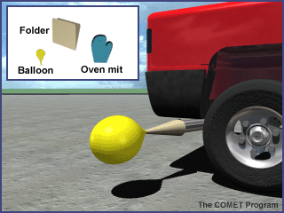
- Blow up and allow the balloons to deflate. This will stretch the rubber and make them easier to fill with the relatively low-pressure exhaust.
- Prepare a cone to collect the car exhaust by rolling up a manila folder lengthwise. One end must be larger than the opening for the car's tail pipe and the other end must be small enough for the balloon to fit over it.
- Use plenty of tape to hold the cone in shape and to make the sides of the cone fairly airtight. Note: the paper funnel will work for several fillings without burning. DO NOT use a plastic funnel. As the exhaust pipe heats up, the plastic may melt. You may use a metal funnel, but be VERY careful to avoid any skin contact with the hot metal.
- Have an assistant turn on the car (make sure brake is on).
- Put the balloon on the small end of the cone.
- Using the heat resistant mitts, approach the exhaust pipe from the side. Place the large end of the cone over the tail pipe. Use the gloved hand to help form a seal between the cone and the exhaust pipe. DO NOT BREATHE THE EXHAUST. The balloon should fill quickly; if not, have your assistant step lightly on the accelerator.
- When the balloon is filled, have an assistant use a twist tie or two to tightly seal the balloon. Do this by twisting the neck several times and doubling it over once, then place the twist tie around the constricted area.
- You will want to have at least one balloon for each group of students. It is useful to prepare a few extra filled balloons.
ASSESSMENT:
In this activity, the students have examined several sources of carbon dioxide. Ask them the following questions:
- If you wished to reduce the amount of increase in the atmosphere, which source would be most important to control? Explain why.
- Would there be problems with such controls? If so, what might they be?
- Ask students to devise their own experiment to test other sources and sinks of carbon dioxide (e.g. carbonated beverages, lime based chalk)
BACKGROUND INFORMATION:
Carbon dioxide has a characteristic that enables students to detect CO 2 in a classroom setting. When dissolved in water, carbon dioxide forms a weak acid, called carbonic acid. The chemical bromothymol blue (BTB) is a sensitive indicator of the presence of acid. When gas containing CO 2 is bubbled through a BTB solution, carbonic acid forms and the indicator turns from dark blue to green, yellow, or very pale yellow depending on the CO 2 concentration (lighter colors mean higher concentrations).
Carbon dioxide (CO 2 ) provides the bubble in your soda pop and the "rise" in your baked goods. But it is also a very significant greenhouse gas. CO 2 is important in maintaining the earth's average temperature of about 15°C (59°F). The CO 2 traps infrared energy emitted from the earth's surface and warms the atmosphere. Without water vapor, CO 2 , and methane (the three most important naturally produced greenhouse gases), the earth's surface would be about -18°C (0°F). At this temperature, it is doubtful that complex life as we know it would ever have evolved.
Where does CO 2 come from? Plants and animals give it off when they extract energy from their food during cellular respiration. CO 2 bubbles out of the earth in soda springs, explodes out of volcanoes, and is released when organic matter burns (such as during forest fires).
Anything that releases CO 2 into the atmosphere (living, dead, or non-living) is considered a source
Anything that absorbs and holds CO 2 from the air or water is considered a sink (because, like a sink in your home, it acts as a "holding reservoir")
Over geologic time, CO 2 sources and sinks generally balance. In today's atmosphere, however, CO 2 levels are climbing in a dramatic and easily measurable fashion, providing evidence that there are now more CO 2 sources than sinks.
Plants and animals give off CO 2 while alive and respiring and when dead and decaying (bacteria that consume the dead bodies respire too, after all). Plants (both terrestrial plants and marine phytoplankton) are important carbon sinks, taking up vast quantities of CO 2 through the process of photosynthesis. While plants also release CO 2 through the process of respiration, on a global, annual basis, the amount of CO 2 taken up by plants through photosynthesis and released through respiration approximately balances out.

