**Unit 3 Project: Design a Non-Profit**

Standards:

SEV4. Students will understand and describe availability, allocation and conservation of energy and other resources

SEV5. Students will recognize that human beings are part of the global ecosystem and will evaluate the effects of human activities and technology on ecosystems.

Directions:

1. Choose a cause from the following list, or create your own idea:

* The Water Crisis
* World Hunger
* AIDS/Disease
* Homelessness

1. Design one printed advertising material (pamphlet, flyer, etc.) and one commercial to promote your cause.

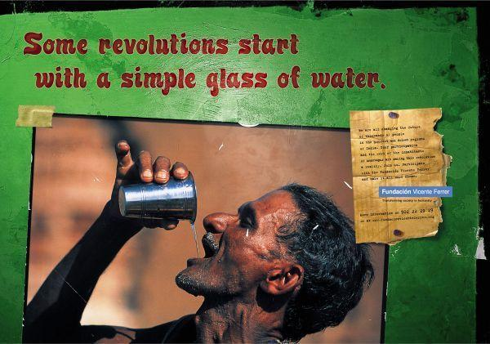

3. Write a one page proposal stating why your non-profit is important and why the general public should support your cause.

**RUBRIC: Create a Non-Profit**

|  |  |  |  |  |  |
| --- | --- | --- | --- | --- | --- |
| Student selected an appropriate cause to create a non-profit for | 1 | 2 | 3 | 4 | 5 |
| Student used creativity in designing print and commercial promotional materials. | 1 | 2 | 3 | 4 | 5 |
| Promotional materials are free of grammatical errors. | 1 | 2 | 3 | 4 | 5 |
| Evidence of research into the cause is represented in the students’ work. | 1 | 2 | 3 | 4 | 5 |
| Proposal is one page in length and relevant to the students cause. | 1 | 2 | 3 | 4 | 5 |
| Proposal is thoughtful and free of grammatical errors. | 1 | 2 | 3 | 4 | 5 |
| Total Points |  | | | |  |
| Letter Grade |  |