Effects of a Closed Environment
on Living Things

Overview
We must understand the interdependent relationships between photosynthesis and animal respiration before we can proceed in developing systems that will allow long term survival in space. Utilizing the processes of photosynthesis and respiration, students investigate living organisms in a closed environment.

Key Question
- What factors are necessary in order to assure that living things can survive and function in a closed environment?
- What happens to plants when they are placed in an environment saturated with carbon dioxide for a period of time?

Materials
For each team of students: •
- 8 test tubes
- 4 aquatic snails
- 8 stoppers
- bromthymol blue solution
- 4 stalks of Elodea
- 1 or 2 liter bottle of club soda
For each student:
- One photocopy each of "Student Record Sheet," "Analyzing Your Data," and "Excess Oxygen Experiment Observations"
For the class:
- 1 Overhead transparency of "Setting Up the Test Tubes"

A Closed Environment ---------------Student Record Sheet
Directions:
Set up a table like the one below to record your data. You will be recording the color of the solutions each day.
Table # 1 Solution Color for Test Tubes with Water Only.
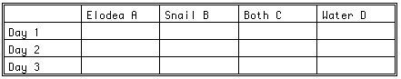
Table # 2 Solution Color for Test Tubes with Bromthymol Blue
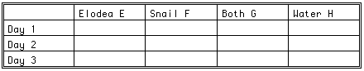
Reflections.
After collecting data, reflect on these questions:
  - Which test tubes were used as controls?
  - What causes the bromthymol blue solution to turn yellow?
  - For each test tube, explain what effects cause the final observed changes.

EXCESS CARBON DIOXIDE EXPERIMENT OBSERVATIONS
Table # 3
Solution Color for Test Tubes Saturated with CO2 & Bromthymol Blue
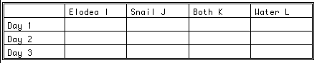
Analysis Questions.
After you have collected data, reflect on these questions.
  - Did any of these tubes go from yellow to clear or blue?
What gas do you suspect replaced the CO2?
  - Tube D should remain yellow in color. Tube H should remain blue in color. Tube L should remain yellow in color. Why will this be the case for each of the tubes? Be specific.
  - Why would each of these tubes (D, L, and H) be considered a control for its group?
  - Which of the three sets of test tubes will be considered the control group? Why did you say that?
  - Did tube I clear? How long did it take? Observe tube K; has it cleared? Why do you think this happens?

A Closed Environment --------------- Analyzing Your Data
- In your observations of tubes E through H which of the tubes, if any, are yellow?

- What is the reason bromthymol blue turns yellow in these tubes?

- Are any of the tubes blue in color? What does blue indicate?

- Are any of them clear? What does clear indicate?

- Which of the tube groups ABCD or EFGH is most likely to remain clear?
Why?

- What do you think is the relationship between photosynthesis and respiration?

- How is this activity relevant to humans in space? What implications does this study have for space travel and for living in a closed environment?

Part A-The Role of CO2 in Living Systems
Procedures:
- Write descriptive sentences using each of these words or phrases: carbon dioxide, plant, animal, waste elimination, general health, behavior, photosynthesis, oxygen, respiration, and indicator.
- a. Fill a 15 ml test tube with about 10 ml of clean aquarium water and add about 3 drops of bromthymol blue solution. Using a soda straw, gently blow into the bottom of the test tube. Is there a color change in this solution? What may account for this color change? Use the above measurements for all test tubes in this lab.
- Observe the aquarium snails in their natural environment. Record any observation that relates to their movement, feeding habits, waste elimination, general health, and behavior.
- Label your test tubes A through H.
- Prepare the following test tubes in this manner.
  - Tubes Contents
A & E One stalk of Elodea
C & G One snail-one Elodea
B & F One water snail
D & H Nothing
- To test tubes A, B, C, and D add water only.
- To test tubes E, F, G, and H add bromthymol blue solution.
- Place a stopper on each of the test tubes and place the tubes in your test tube rack.
- Place the racks near a light source. See Illustration 1

Illustration 1. Setting Up the Test Tubes
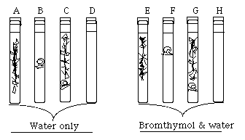

Part B-Effects of Excess Carbon Dioxide On Plants
- Instruct the students to set up a new experiment.
- Wash and reuse the four test tubes that you have previously set up (ABCD), replacing the Elodea and snails as appropriate.
- Relabel these test tubes IJKL.
- Add three drops of bromthymol blue to each of these test tubes.
- Saturate the air space in each test tube with CO2 from a liter bottle of club soda and seal with a stopper.
See Illustration 2.
- Record observations on the "Excess Carbon Dioxide Experiment Observations" sheet.
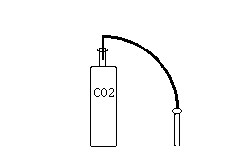
Illustration 2

Background for Teachers
As Earthlings, regardless of the efforts we take and the costs we assume, it's impossible to replicate on Earth exactly the conditions found in space. Students can simulate the kinds of problems living systems encounter in the space environment and reproduce some aspects of that environment in the classroom.
In this activity, we are attempting to replicate a closed system such as that found in a spacecraft or habitat. For life in space, provisions must be made for food supplies, oxygen, gravity, energy, and the disposal (or reclamation) of CO2 and waste for both humans and plants. By placing snails in a closed system with certain plants, we can take a look at the reactions necessary for the survival of living things.
We can start this experiment with the study of photosynthesis and respiration-both plants and animals are dependent upon this reaction. On current missions, we do not grow plants in spacecraft in order that astronauts may breathe the oxygen-O2 is supplied artificially. The same is true with all other living system needs; such as waste and CO2 removal, and the provision of O2 and energy (food and light)-all are artificially supplied. In the future, we would like to create self-supporting systems so that astronauts living in space will have a renewable source of oxygen gas-thus the emphasis in growing plants in space.

