Station 1: Who developed the Atom?
Label Station 1 in your notebook. Use the cards in the plastic bag to organize the Atomic Theory discoveries in order of the year they were developed, beginning with the earliest year.
In your notebook record the following: The letter of the cards in the order which you placed them, Identify the scientist that made each discovery next to the letter, write 3-5 sentences about modern day atomic theory including the location, charge and mass of each subatomic particle.

A: Electrons orbit in fixed distances from the nucleus, called orbitals

B: Used the cathode ray tube experiment to develop the “Plum Pudding Model”

C: Everything is made up of atoms

D: Used the Oil Drop Experiment to discover the charge of the electron

E: Discovered the proton and the dense, positively charged nucleus after conducting the Gold Foil Experiment

F: Developed 5 ideas about the atom including that atoms of one element can combine with atoms of another element to form compounds.

Station 2: Predicting Periodic Trends!
Label Station 2 in your notebook. Type in http://www.sciencegeek.net/Chemistry/taters/Unit2PeriodicTrends.htm
on the internet to open the Periodic Trends Review Quiz. In your notebook record: your answer to each question completed (just write the letter choice) and your total score at the end of the quiz. Work independently on your own quiz, but you may ask your group members to better understand a question.

Station 3: Metals, Nonmetals and Metalloids
Label Station 3 in your notebook. Observe the substances inside each beaker. In your notebook record: the letter of each beaker and if the substance is a metal, nonmetal or metalloid. Write 1 sentence for each group about why you classified the substances the way you did. Create a list of 5 properties for metals and 5 properties for nonmetals that can help you classify substances. Use the text book to assist you with determining properties.

Station 4: Atomic Mass and Isotopes
Label Station 4 in your notebook. Use the pictures of the atoms below to calculate the weighted atomic mass of the element. In your notebook record: a. How do you know these atoms are isotopes of each other? B. What is an isotope? C. Calculate the weighted atomic mass of the element and show all work. D. Identify the element from the Periodic Table.
Remember: Atomic Mass = Protons + Neutrons!
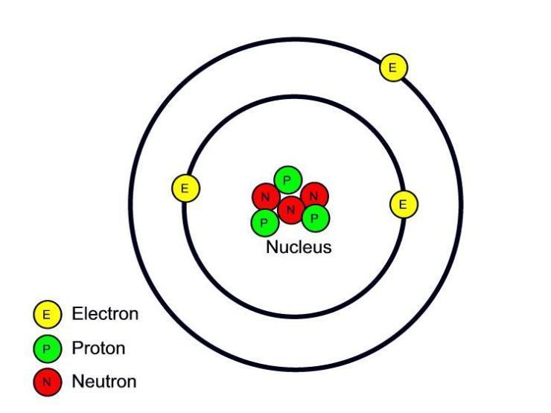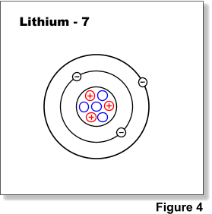

Atomic Mass = ________________ Atomic Mass = ________________
Abundance: 92.5% Abundance: 7.5%

Station 5: Periodic Table Organization
** Nothing from this station will be recorded in your notebook!
Create a poster using chart paper of the organization of the Periodic Table. Include Groups 1, 2, 13-18. You do not need to draw each element square, just the outline of the group will be plenty. Name group 1,2,17, and 18. Write the number of valence electrons above each group. Identify what element is in Period 4 and group 15. Draw the element square for this element and label the name, symbol, atomic mass, atomic number, number of valence electrons, and if it will have a higher or lower ionization energy than Potassium.

Station 6: Electron Configuration
Label station 6 in your notebook. On a clean piece of paper in your notebook record the following: Create a step-by-step guide on how to write orbital diagrams and electron configurations for electrons located in the atom. Include the 3 rules to drawing the orbital diagram and what this diagram represents. What are the steps to writing the electron configuration? Do an example using Oxygen to help explain your steps. Write your steps as if you are teaching someone who has never heard of this concept before. If you would like to use computer paper and staple it into your notebook, you may.

