Mystery of the Bones

The Scene
In a quiet camping area known as Crystal Lake, four complete human skeletons were found in the mud when the lake began to dry during a drought. Detectives checked the missing person's reports for people in the area and found that five people had disappeared from that area over the last 10 years.
Oddly, the skeletons were almost completely intact due to being somewhat preserved in the clay at the bottom of the lake.
~ Author's Note: These are ficticious characters in a ficticious crime scene

Crystal Lake
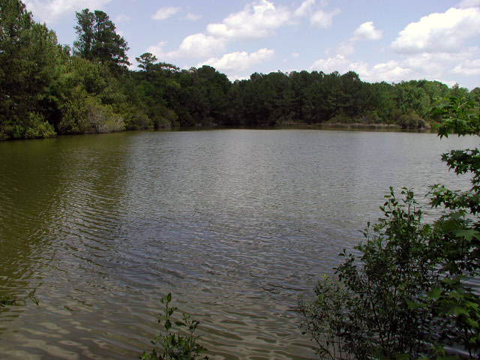

Photos of Remains Found There
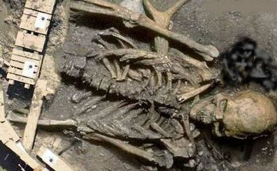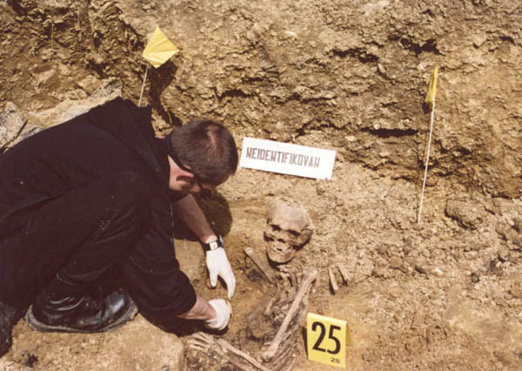

(Pretend) Missing Persons |  | Evidence Files
 | Name: Sara Munchausen  Age: 21  Height: 5'0  Weight: 105 lbs | Bones Set 1  Bones Set 2  Bones Set 3  Bones Set 4  Instructions  1. Each team member should pick a bone set and reconstruct the skeleton using glue, scissors and tape.  2. Each bone of the skeleton should be labeled  3. Next you will need to determine the identity of the bones based on age and height  a. Determine the gender of your subject by looking at the shapes of specific bones  b. Use the following formula to determine the height of your subject  Your "paper" skeleton is not a real skeleton. Assume that 1cm on your paper skeleton = 8.6 cm on the real skeleton  Male (real) (2.32 x length of the femur in cm.) +65.53 ± 3.94  Female (real) (2.47 x length of the femur in cm.) + 54.10 ± 3.72  Feet to Cm height conversion  4. On your reconstructed skeleton, include information about the gender and height of the skeleton and point out your reasoning for your claims (include formulas or arrows to bones, etc)  5. Who is your “missing person”? ______________; Explain why you chose this individual.
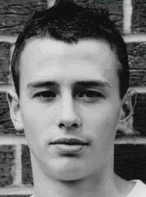 | Name: Jamie Matthews  Age: 18  Height: 6'2  Weight: 190 lbs
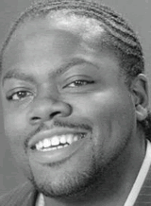 | Name: Neil Baxter  Age: 22  Height: 6'1  Weight: 210 lbs
Name: Robert Downey
Age: 45
Height: 5'7
Weight: 190 lbs
Name: Eva Longori
Age: 55
Height: 5'8
Weight: 140 lbs

Bones Set 1
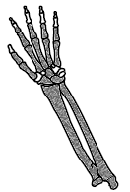 | 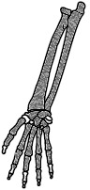 | 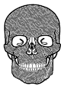
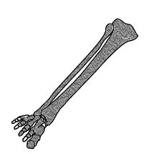 | 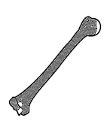 | 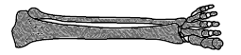
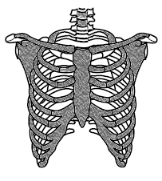 |  | 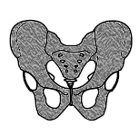
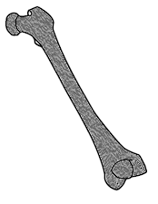 | 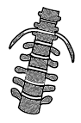 | 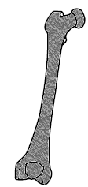

Bones Set 2
 | 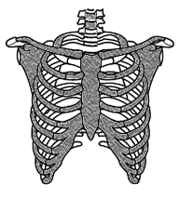 |  | 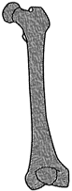
 |  | 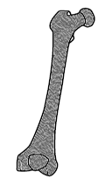

Bones Set 3
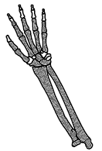 |  | 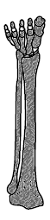 | 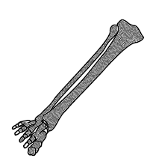
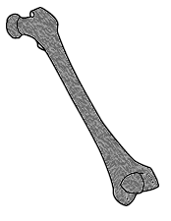 | 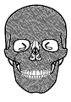 | 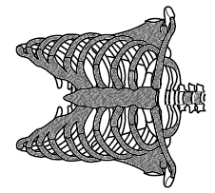 | 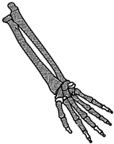
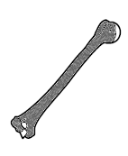 | 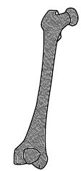 | 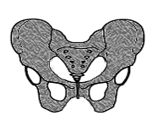 | 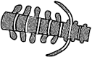

Bones Set 4
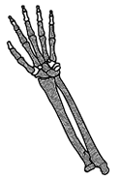 | 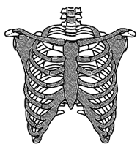 | 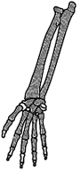
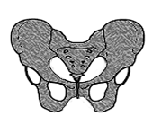 | 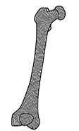 | 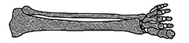
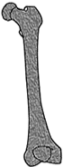 | 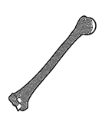
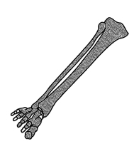 | 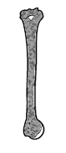 | 