Species Interactions Field Investigation

Purpose:
The purpose of this field activity is to observe examples of species interactions in a field setting.

Materials:
• Paper
• Pencil
• Field guide of organisms native to you area (these may be checked out from most local libraries)
• Magnifying glass (hand lens)
• Binoculars

Procedure:
1. Put the above materials into a bag or backpack, put on a comfortable pair of shoes, and find a spot outdoors that is quiet and secluded. In this activity you will be looking for real examples of species interactions. You need to find a minimum of seven examples representing at least three of the five types of species interactions.
2. Find a quiet, comfortable place to sit down and remain quiet and still for at least
30 minutes. Carefully watch for examples of species interactions among the animals and insects around you. Use your binoculars if they will aid you in making observations.
3. Write down all of your observations. What organisms are involved in the interaction? If in doubt use your field guide to identify the organisms. Which of the five types of species interaction are they engaged in? If predation, who is the predator and who is the prey? If parasitism, who is the parasite and who is the host.
4. Now, take a walk and look for additional examples of species interactions. Pay special attention to plants during this part of the field activity. Use your binoculars and/or hand lens if they will aid you in making observations.
5. Write down all of your observations. What organisms are involved in the interaction? If in doubt use your field guide to identify the organisms. Which of the five types of species interaction are they engaged in? If predation, who is the predator and who is the prey? If parasitism, who is the parasite and who is the host.

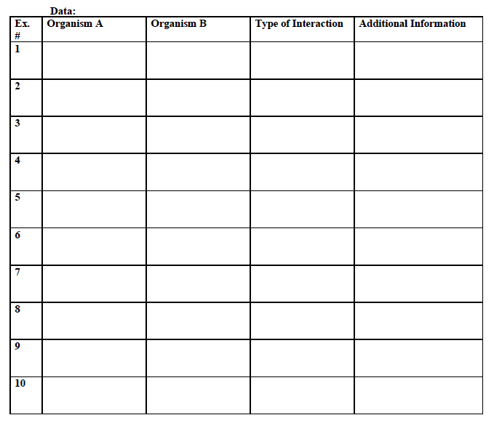
Conclusion:
Write a two to three paragraph description of your experience. Where did you conduct your field activity? What types of organisms did you observe? What type of species interaction seemed to be the most common? Did you observe more interactions involving plants or animals? What did you learn? What would you do differently if you were to conduct this field investigation again?

